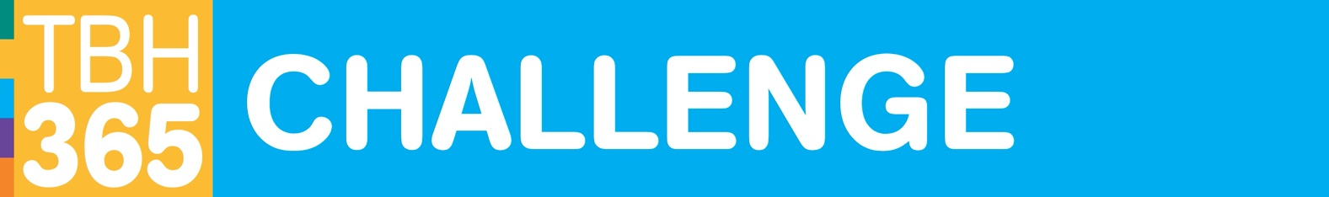
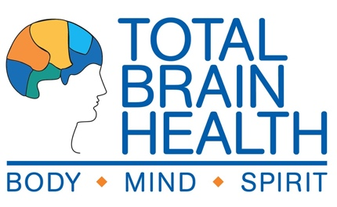
GET THE WORD OUT! RESOURCES

TBH365 CHALLENGE OUTREACH PACKET

- Sample Press Release

- Sample Newsletter Announcement

- TBH365 Challenge Description

- Total Brain Health Log

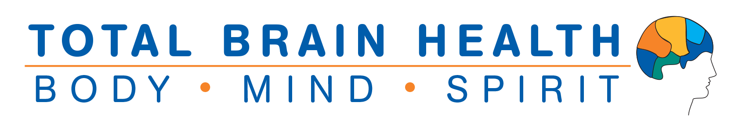

TBH365 CHALLENGE
SAMPLE PRESS RELEASE

Use the sample press release below as a guide to your own announcements of the TBH365 Challenge Program to the local press, for your newsletter, blog, or other outlets.

(YOUR LOCATION NAME) TO HOST A BRAIN FITNESS CHALLENGE
Expert-Designed Training That Motivates, Inspires and Connects for Better Brain Power!

(Location City/State, Date). Cognitive decline is a fear many share, especially those over 50. Yet the research shows leading a healthy lifestyle may in fact be the very best medicine to keep us sharp and lower our risk for serious memory loss. As the Lancet Commission on Dementia Prevention, Intervention and Care recently stated, “When it comes to dementia prevention, modifying a combination of 12 risk factors throughout our lives might prevent or delay up to 40% of dementias.”

This (time frame), (your location name) will offer everyone the chance to boost their brainpower with an empowering, fun challenge-based program designed by leading brain fitness provider Total Brain Health. The Total Brain Health TBH365 Challenge combines Total Brain Health’s TBH TOOLBOX365 personal training program, with community group meetups that support and educate on the latest in cognitive fitness.

Every (your meetup schedule) trainers will kick off a friendly challenge competition designed to build better brain health. Challenges will encourage and reward participants for working on their own or together as they practice ways to bring the cutting-edge brain science into their daily routines.

The TBH365 Challenge meetups will run from (date frame on your calendar) and are open to all (residents/community members/family/anyone).

The innovative program uses a game-based approach to teaching the many different ways we can use our lifestyle to boost cognitive well-being. “We look forward to offering the TBH365 Challenge program at (your location name). This program adds fun to the way we promote cognitive well-being, so central to healthy aging,” says (Name, Title) of (your location name).

As leaders in the field of cognitive fitness, Total Brain Health uses a proprietary training approach that teaches brain-boosting lifestyle interventions through social engagement and hands-on learning. “At Total Brain Health, we believe that all minds can thrive. The tools we develop help everyone get smarter about their brain health. Our TBH365 Challenge program combines robust personal engagement with a gamified approach everyone can use to train for better cognitive wellness,” says Total Brain Health’s Dr. Cynthia Green

To learn more or register for the program, call (phone number) or email (email address).
___________

About Total Brain Health. A leader in the field of cognitive fitness, Total Brain Health delivers tools everyone can use to build better brain health, no matter their age or ability. Backed by three decades of research, TBH training programs teach effective steps to boost brainpower and improve cognitive vitality using highly social, fun and engaging workouts. Products include TBH Toolkits, social-based brain training for groups, and TBH Toolbox365, a daily cognitive training solution for individuals and TBH365 Challenge with personal and group training combined.

About (your location name). (Company information and logo).

TBH365 CHALLENGE
SAMPLE NEWSLETTER ANNOUNCEMENT

Use the sample copy below as a guide to your own announcement for internal outlets such as a community newsletter, calendar, e-portal or other communications.

JOIN THE TOTAL BRAIN HEALTH TBH365 CHALLENGE!

Come join us as we “get smart” about brain health! Developed by the leading brain fitness experts at Total Brain Health, the TBH365 Challenge combines Total Brain Health’s TBH TOOLBOX365 personal training with group-based education and support meetings. Friendly competitions will motivate, inspire, and connect us - and keep the training fun!

You will:

- Discover the cutting-edge science behind how our lifestyle may be the best way we can sharper thinking and reducing our risk for memory loss.
- Train on your own, with friends or family with engaging workouts that give you the chance to try the many ways we can promote our cognitive health
- Earn points for completing TBH365 workouts, and even more points for engaging in the special challenge workouts
- Join your teammates for regular “meetups” where we will learn more about the brain health science, train together, and track our progress – and have fun!

Our TBH365 Challenge meetings will be on (day) at (times) in the (location).

For more information, contact (name) at (contact information).

TOTAL BRAIN HEALTH AND TBH365 CHALLENGE LOGOS

Permission is provided to use the Total Brain Health logos below to identify the course and/or to promote your affiliation with Total Brain Health. For all other permitted uses contact us at info@totalbrainhealth.com.

Please note that Total Brain Health© and TBH© within the use of educational materials are trademarked to Total Brain Health, with all rights reserved.

TBH LOGO DESCRIPTION | LOGO (JPEG)
TOTAL BRAIN HEALTH© LOGO | 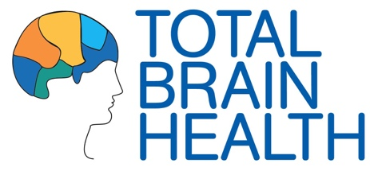
TOTAL BRAIN HEALTH© LOGO WITH WELLNESS BRANDING | 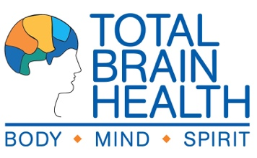
TBH© TOOLBOX365 LOGO (GENERAL) | 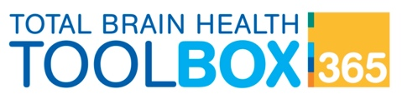
TBH365 CHALLENGE LOGO | 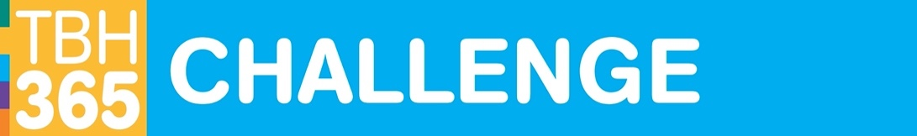
URLS | totalbrainhealth.com | tbhtoolbox365.com

